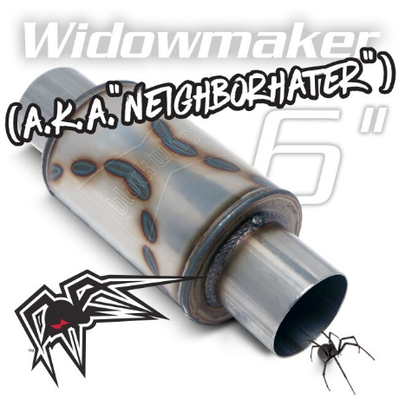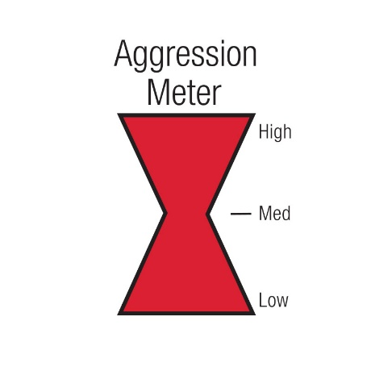
Part Number | Inlet/Outlet | Body Length | Overall Length | Body Type
BW0012-25 | 2.5”-2.5” | 6” | 12” | 5” Round
BW0012-30 | 3”-3” | 6” | 12” | 5” Round
BW0012-35 | 3.5”-3.5” | 6” | 12” | 5” Round
BW0012-40 | 4”-4” | 6” | 12” | 5” Round

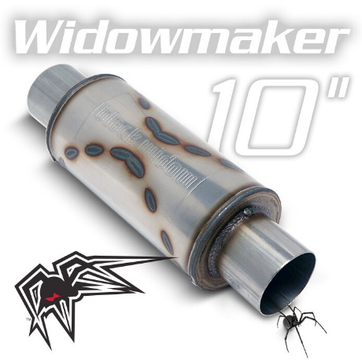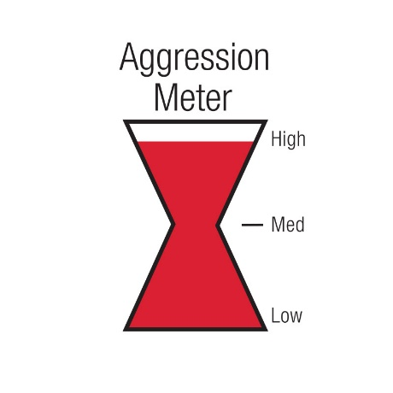
Part Number | Inlet/Outlet | Body Length | Overall Length | Body Type
BW0013-2 | 2.5”-2.5” | 10” | 16” | 5” Round
BW0013-3 | 3”-3” | 10” | 16” | 5” Round
BW0013-35 | 3.5”-3.5” | 10” | 16” | 5” Round
BW0013-4 | 4”-4” | 10” | 16” | 5” Round

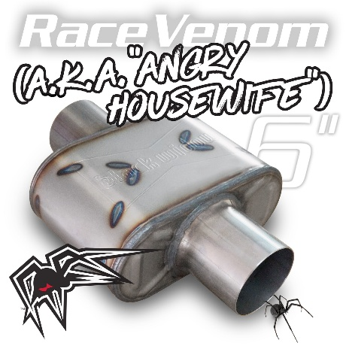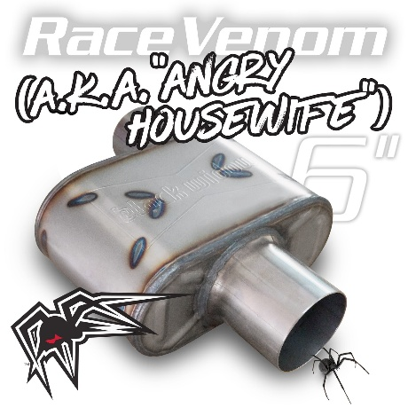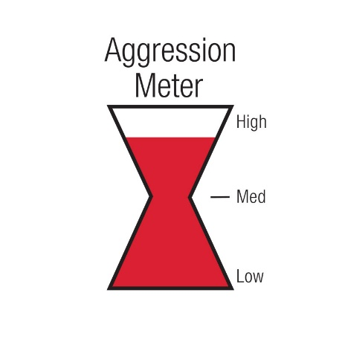
Part Number | Inlet/Outlet  Configuration | Body Length | Overall Length | Body Type  (HxW)
BWAHW25-C | 2.5”-2.5”  C/C | 6.5” | 12.5” | 4.25”x9.25”  Oval
BWAHW25-P | 2.5”-2.5”  O/C | 6.5” | 12.5” | 4.25”x9.25”  Oval
BWAHW30-C | 3”-3”  C/C | 6.5” | 12.5” | 4.25”x9.25”  Oval
BWAHW30-P | 3”-3”  O/C | 6.5” | 12.5” | 4.25”x9.25”  Oval
BWAHW35-C | 3.5”-3.5”  C/C | 6.5” | 12.5” | 4.25”x9.25”  Oval
BWAHW35-P | 3.5”-3.5”  O/C | 6.5” | 12.5” | 4.25”x9.25”  Oval
BWAHW-32 | 2.5”-2.5”  S/D | 6.5” | 12.5” | 4.25”x9.25”  Oval
BWAHW-33 | 3”-3”  S/D | 6.5” | 12.5” | 4.25”x9.25”  Oval
BWAHWDD-22 | 2.5”-2.5”  D/D | 6.5” | 12.5” | 4.25”x9.25”  Oval
BWAHWDD-33 | 3”-3”  D/D | 6.5” | 12.5” | 4.25”x9.25”  Oval
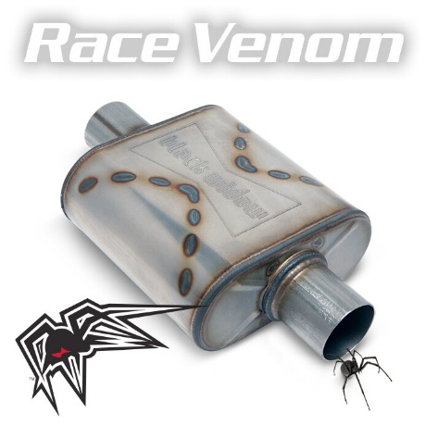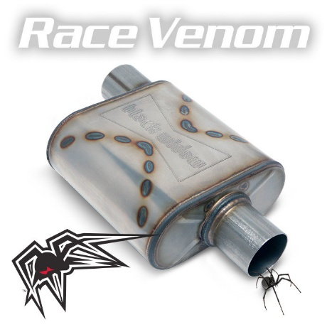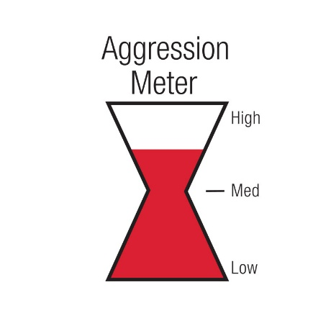
Part Number | Inlet/Outlet  Configuration | Body Length | Overall Length | Body Type  (HxW)
BW009-C | 2.5”-2.5”  C/C | 9” | 15” | 4”x9”  Oval
BW009-P | 2.5”-2.5”  O/C | 9” | 15” | 4”x9”  Oval
BW0010-C | 3”-3”  C/C | 9” | 15” | 4”x9”  Oval
BW0010-P | 3”-3”  O/C | 9” | 15” | 4”x9”  Oval
BWOOR-22 | 2.5”-2.5”  O/O | 9” | 15” | 4”x9”  Oval
BWOOR-33 | 3”-3”  O/O | 9” | 15” | 4”x9”  Oval
BW0011-P | 3.5”-3.5”  O/C | 9” | 15” | 4”x9”  Oval
BW0011-C | 3.5”-3.5”  C/C | 9” | 15” | 4”x9”  Oval
BWSDR-32 | 3”-2.5”  S/D | 9” | 15” | 4”x9”  Oval
BWSDR-33 | 3”-3”  S/D | 9” | 15” | 4”x9”  Oval
BWDDR-22 | 2.5”-2.5”  D/D | 9” | 15” | 4”x9”  Oval
BWDDR-33 | 3”-3”  D/D | 9” | 15” | 4”x9”  Oval
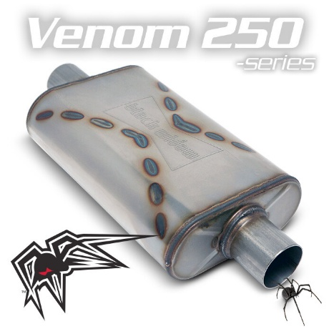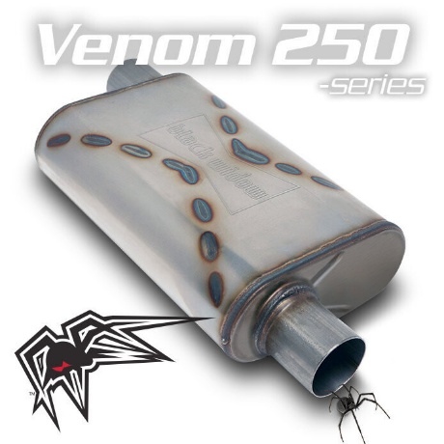
Part Number | Inlet/Outlet  Configuration | Body Length | Overall Length | Body Type  (HxW)
BW001-C | 2.5”-2.5”  C/C | 14” | 20” | 4”x9”  Oval
BW001-P | 2.5”-2.5”  O/C | 14” | 20” | 4”x9”  Oval
BW002-C | 3”-3”  C/C | 14” | 20” | 4”x9”  Oval
BW002-P | 3”-3”  O/C | 14” | 20” | 4”x9”  Oval
BWOOV2-22 | 2.5”-2.5”  O/O | 14” | 20” | 4”x9”  Oval
BWOOV2-33 | 3”-3”  O/O | 14” | 20” | 4”x9”  Oval
BWSDV2-32 | 3”-2.5”  S/D | 14” | 20” | 4”x9”  Oval
BWSDV2-33 | 3”-3”  S/D | 14” | 20” | 4”x9”  Oval
BWDDV2-22 | 2.5”-2.5”  D/D | 14” | 20” | 4”x9”  Oval
BWDDV2-33 | 3”-3”  D/D | 14” | 20” | 4”x9”  Oval
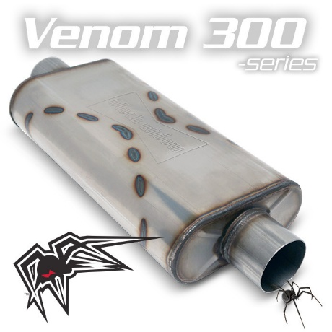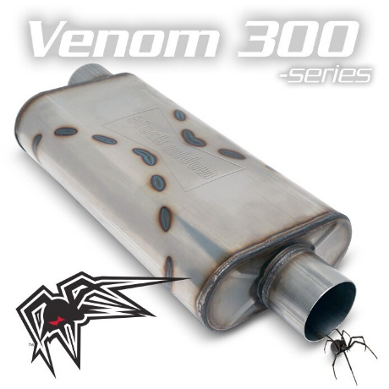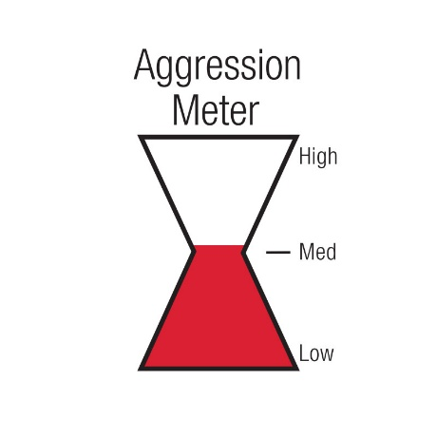
Part Number | Inlet/Outlet  Configuration | Body Length | Overall Length | Body Type  (HxW)
BW005-C | 2.5”-2.5”  C/C | 18” | 24” | 4”x9”  Oval
BW005-P | 2.5”-2.5”  O/C | 18” | 24” | 4”x9”  Oval
BW004-C | 3”-3”  C/C | 18” | 24” | 4”x9”  Oval
BW004-P | 3”-3”  O/C | 18” | 24” | 4”x9”  Oval
BWOOV3-22 | 2.5”-2.5”  O/O | 18” | 24” | 4”x9”  Oval
BWOOV3-33 | 3”-3”  O/O | 18” | 24” | 4”x9”  Oval
BWSDV3-32 | 3”-2.5”  S/D | 18” | 24” | 4”x9”  Oval
BWSDV3-33 | 3”-3”  S/D | 18” | 24” | 4”x9”  Oval

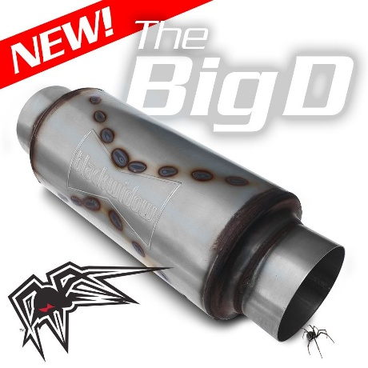
Part Number | Inlet/Outlet | Body Length | Overall Length | Body Type
BWBIGD-35 | 3.5”-3.5” | 14.75” | 21.75” | 7.5” Round
BWBIGD-4 | 4”-4” | 14.75” | 21.75” | 7.5” Round
BWBIGD-45 | 4.5”-4.5” | 14.75” | 21.75” | 7.5” Round
BWBIGD-5 | 4”-4” | 14.75” | 21.75” | 7.5” Round

